Inspiring Communities Together
Application Pack

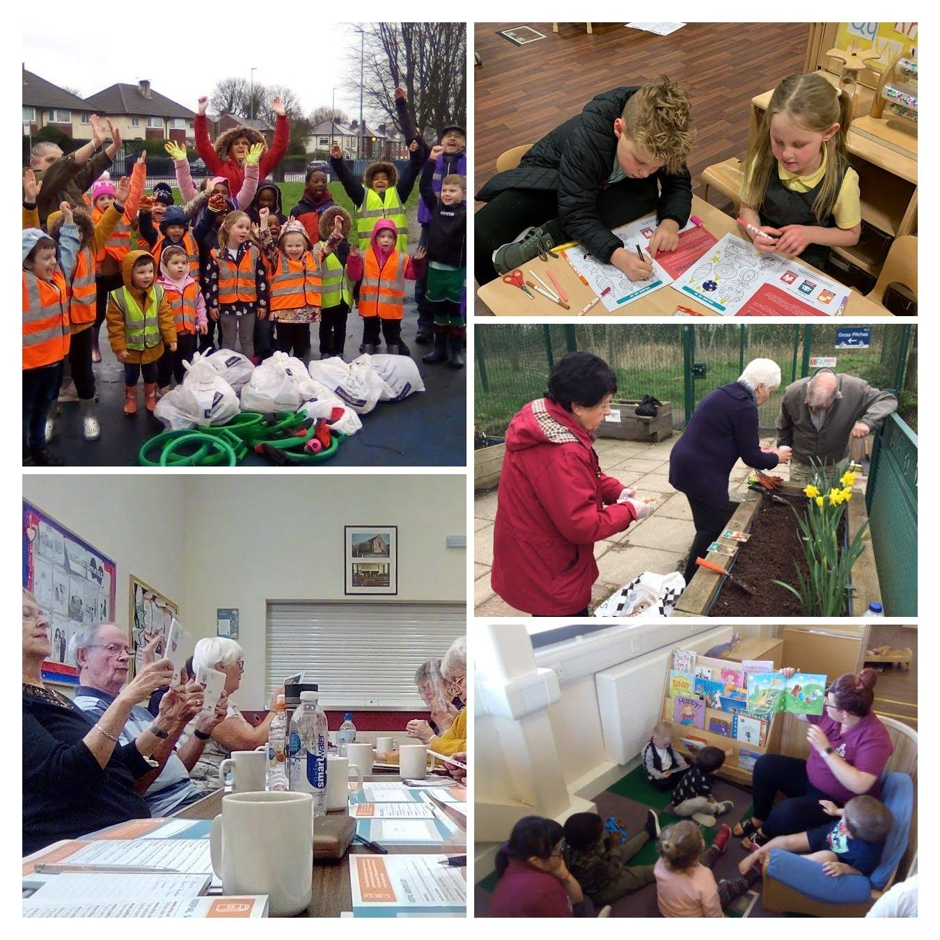
Child and Families Manager
(Children and Families)

Closing Date: 9am, Monday 8th January 2024

Interview Date: TBC

Introduction

Thank you for considering applying for the role advertised. This pack has been created to help you learn more about Inspiring Communities Together and ensure that you complete a good quality application.

Please do visit our website as we want applicants to be able to understand who we are as an organisation and also to be able to demonstrate how their skills and experience meet the requirements of the advertised role.

About the role
Inspiring Communities Together has been through a transformational change on how we think about supporting children and families from offering play and stay provision to supporting working families and offering the best start in life to our younger members of the community. Our children early years offer is delivered from Sport Village as a one room setting (2 years – 4 years of age)

Our Children and Families Programme is led by our Children and Families Manager and this position will play a key role is connecting families to our wider family offer including advice and guidance and relationships with local primary schools.

About you
We are looking for someone who is passionate about supporting children and families, is able to lead the childcare team, engage with families we work with including sign posting to our wider organisational offer and connecting with our partners.

You will be confident at building up new relationships and keen to offer ideas and solutions to solve problems and improve our service delivery. Please be aware that this post is subject to a Enhanced Disclosure and Barring Service (DBS) check which Inspiring Communities together will cover the cost of.

About the benefits
You will be welcomed into a friendly environment where your personal and professional development will be encouraged. You will have the opportunity to work and grow in a people-centred and values based organisation that promotes a positive permission culture.

Your work-life balance and wellbeing are important to us so you will have access to a range of benefits including:

- Living wage Employer
- Funded DBS Check and claim back of annual update service fee
- Comprehensive In house E Learning
- Core Hours 8:30 – 17:00 (Two week stand down holiday periods during Summer and Christmas)
- 26 day leave entitlement plus Bank Holidays
- 35 hour working week for all full time staff
- Health and Wellbeing Programme – including access to 24/7 counselling and support line
- Free Onsite Parking

Equality and Diversity
We are committed to developing a culture which respects individuals, appreciates difference and allows everyone regardless of background to reach their full potential. We understand how hard it can be to combine caring for a loved one with work, so we aim to provide support and flexibility to balance family and caring responsibilities with work.

Information for applicants

In this pack we have provided you with information and guidance to help you through the application process but should you have any difficulties please do not hesitate to contact Carol Hyde Programme Manager (Children and Families) via email on childcare@inpiringcommunitietogether.co.uk

All applications must be submitted by email and completed electronically. No handwritten applications will be accepted. Application is via CV and covering letter. Please note that applications will not be considered where a complete CV and covering letter outlining suitability against the person specification is not submitted.

Please complete and return the equality monitoring from with your CV and covering letter.

Your CV should be no more than two sides of paper and should contain:
- A summary of your employment history
- Any relevant qualifications, including education
- Personal information
- Details of two references who we may contact if you are offered the position

Please ensure your covering letter (no more than 2 sides of paper) includes the following information:

- Your suitability for the role against the person specification outlined below. This is a key part of the process which allows you to provide evidence of your experience, knowledge, skills and abilities that are relevant to the role as described in the role profile.
- At least one example of your previous experience (paid work or volunteering) for each person specification requirement.

Top tips
- Don't be afraid to highlight your accomplishments and unique selling points and don't shy away from confidently stating you can carry out certain competencies well.
- Don’t rewrite your CV - your cover letter and CV should work together but they shouldn't repeat each other. Use your cover letter to add context and detail to certain skills and experiences mentioned in your CV - always keeping in mind the job description/person specification.
- Don’t write your life story - it's easier to waffle in your cover letter than on your CV but don't fall into this trap. You need to keep cover letters concise and to the point.
- Don’t forget to proofread - Your cover letter is your first impression. If your letter includes any misspelled words or grammatical errors, that becomes our first impression of you.
- Don’t use a standard template – It is easy to copy and paste from a standard template but this just shows you have not spent time selling yourself.

Please return you completed documents by 9am, [ 8th April 2024 ] to childcare@inspiringcommunitiestogether.co.uk using the reference CFM in the subject header.

Interview date to be confirmed

Acknowledgement and feedback

You will receive an email acknowledgement of your completed application. Should you be unsuccessful at the shortlist stage, you will be notified by email. Invitations to interview will be sent via email.

All unsuccessful applicants are welcome to ask for feedback on the reasons for not being shortlisted or selected at interview stage. Feedback for not being shortlisted will only be given by email.

Feedback following non-selection at interview stage can be given by email or telephone at an agreed time.

Successful applicants are required to become members of Inspiring Communities Together.

Thank you for your interest in Inspiring Communities Together. Please take care of yourself and those around you.
Yours sincerely
Bernadette Elder
Chief Executive Officer

Job Description – Children and Families Manager

Inspiring Communities Together

35 hours per week

Job title: | Children and Families Manager (Yogurt Pots)
Team: | Children and Families
Salary: | £24,915.80 (£13.69 per hour)
Hours: | 35 hours per week (may consider term time only hours)  must be flexible to meet the needs of the post
Location: | Yogurt Pots Childcare Provision, Sports Village – will also be required to work from main office at Innovation Forum at least once a week
Responsible to: | Children & Families Programme Manager

Job Overview

- To develop, oversee and manage the provision of a range of early year’s education for children and families within Charlestown and Lower Kersal
- To support the involvement and ongoing development of staff, volunteers and family members in delivery of children and family activities to ensure children have the best start in life
- To work as part of the Team responsible for the deliver the Children and Families Strategy.
- Work closely with our Programme Manager (Children and Families) to provide a holistic package of support for families in Charlestown and Lower Kersal

MAIN DUTIES AND RESPONSIBILITIES

Operational and compliance

The post holder will be expected to:
- Lead the development and daily management of the childcare setting providing a safe, caring and stimulating environment of children, including those with Special Educational needs.
- Ensure that all Ofsted registration and inspection requirements are met
- Promote and foster a working environment in which the psychological, physical, developmental and educational well-being of children is paramount
- Ensure that a supportive, empathic and non-judgemental approach is used by all staff and volunteers when interacting with children and their families
- Identify, secure and manage the resources required to deliver a good quality children and families programme including the recruitment, induction and training of all childcare staff and volunteers using safer recruitment guidelines
- Ensure the setting has an allocated Deputy Manager on duty each day

- Work with the staff team to develop programmes which meet the needs and aspirations of the children attending the setting – including identifying and accessing external support when required
- Ensure regular contact and feedback to family members on child development using on-line tools (Tapestry)
- Ensure all staff are trained and using on-line organisational tools including Tapestry and contact management system to ensure personal data is held securely in line with current GDPR legislation
- Signpost family members to wider organisational opportunities and external opportunities including learning and volunteering opportunities and information, advice and guidance support as appropriate

Human Resources

- Development of workforce plans to meet the operational requirements of the
organisation
- Supervise the childcare staff team ensuring regular recorded line management support to all staff and volunteers including providing constructive feedback
- Ensuring good quality recruitment, induction and HR support is in place for staff roles

Managerial

- To work as part of the management team to achieve organisational targets.
- Provide regular monitoring reports as required
- To work with the finance team to manage the childcare budgets ensuring payments are collected and action taken to manage non-payments
- Contribute to the development and delivery of initiatives to improve efficient and effectiveness of the service including new ideas to improve standards

Other
- To support the Children and Families team to achieve the wider organisational objectives
- To attend team meetings, supervision sessions and any external meetings as required
- To work flexibly and undertake, when required, other duties associated with supporting the needs of the organisation, which may be reasonably determined by the line manager and/or Senior Management Team
- To work flexibly and attend occasional meetings and events outside normal working hours (evenings and weekends) for which notice will be given
- To undertake training and professional development as and when required
- Ensure high levels of professional conduct including punctuality, dress, presentation and administration
- Comply with the policies of Inspiring Communities Together at all times

Please note that because this job may involve working with young people and vulnerable adults, we will ask you to complete Enhanced DBS check. You must tell us in your application if you have any convictions, bind-overs or cautions, even if they are spent under the Rehabilitation of Offenders Act 1974. Please note that disclosing a conviction does not necessarily bar you from appointment.

Review arrangements

The details contained in this job description reflect the content of the job at the date it was prepared. It should be remembered, however, that it is inevitable that over time, the nature of individual jobs will change, existing duties may no longer be required and other duties may be gained without changing the general nature of the duties or the level of responsibility entailed. Consequently, the organisation will expect to revise this job description from time to time and will consult with the postholder at the appropriate time.

Date job description prepared/revised:

Prepared/revised by: Carol Hyde November 2023

Agreed job description signed by holder:

Personal Specification

Note to applicants:
Whilst all criterions below are important, those under the Essential heading are the key requirements. You should pay particular attention to these areas and provide evidence of meeting them. Failure to do so will mean that you will not be invited for interview.

Essential Criteria

 | Necessary requirements – skills, knowledge, experience etc. | Assessment
E | Minimum Level 3 NVQ Childcare qualification
E | Ability to support and monitor staff and students
E | At least 2 years experience in working with children within an early years setting
E | Experience of implementation of EYFS, revised EYFS 21
E | Paediatric first aid qualification (if not in possession of this, must be achieved within 3 months of employment)
E | Knowledge of legislation relevant to Early Years such as EYFS 21, SEN, safeguarding, Childcare Act 2006
E | Knowledge of Child Development and children’s needs, including additional support needs
E | Ability to work with parents/carers/families to encourage partnership working
E | Ability to communicate well with adults and children
E | Ability to work as part of a team
E | Knowledge of how a children and families model works

Desirable Criteria

D | Good IT skills including using Word, Excel and PowerPoint
D | Food Hygiene Level 2 (if not in possession of this, must be achieved within one months of employment)
D | Knowledge of online reporting systems such as Tapestry
D | Local resident of Charlestown and/or Lower Kersal
D | Extensive knowledge of Charlestown and/or Lower Kersal
D | Full clean driving licence with access to a car

Personal qualities
Ability to act honestly, reasonably and with integrity
Active commitment to equality and diversity
Commitment to promoting the core values of the organisation

Inspiring Communities Together Equality Monitoring Form

At Inspiring Communities Together, we want to know that we are giving people equal opportunities throughout all aspects of our work. To ensure this happens we need to collect information from you. Please help us by answering the following questions

The information you provide will be used solely for monitoring purposes and will be treated as confidential

- I would describe my origin as (please tick as appropriate)

WHITE |  | MIXED BACKGROUND |  | ASIAN OR ASIAN BRITISH
English |  | White and Black Caribbean |  | Indian
Scottish |  | White and Black African |  | Pakistani
Welsh |  | White and Asian |  | Bangladeshi
Irish |  | Other mixed Background |  | Other Asian background
Other White background
BLACK OR BLACK BRITISH |  | CHINESE, CHINESE BRITISH OR OTHER ETHINIC GROUP
Caribbean |  | Chinese
African |  | Other background
Other Black background

2. | My gender is:
Male |  | □ | Female | □
Prefer to self-describe |  | □ | Prefer not to say | □

3. Please tick if you identify as LGBTQ+ □

4. Do you consider you have a disability? Yes No

5. Age: under 18 18-30 31-60 over 60

