Inspiring Communities Together
Application Pack

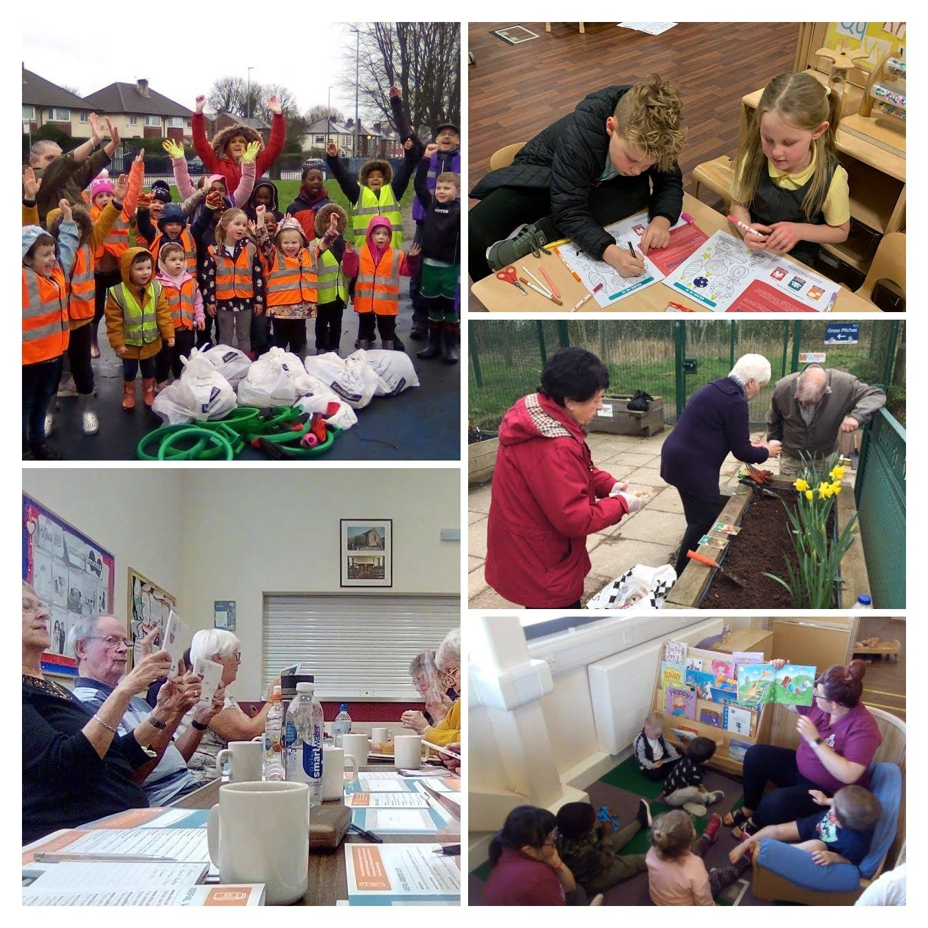

Child Care Apprenticeships
(Children and Families)

Closing Date: 9am, xxxx
Interview Date: TBC

Introduction

Thank you for considering applying for the roles advertised. This pack has been created to help you learn more about Inspiring Communities Together and ensure that you complete a good quality application.

Please do visit our website as we want applicants to be able to understand who we are as an organisation and also to be able to demonstrate how their skills and experience meet the requirements of the advertised role.

Information for applicants

In this pack we have provided you with information and guidance to help you through the application process but should you have and difficulties please do not hesitate to contact Carol Hyde Programme Manager (Children and Families) via email on office@inspiringcommunitiestogether.co.uk

All applications must be submitted by email and completed electronically. No handwritten applications will be accepted. We do not accept CVs; a full application form must be completed. Anyone submitting a CV or not completing the application as outlined below will not be considered by the panel.

Each applicant is required to submit the following information as part of the application process:
- The completed application form
- Equality monitoring form
- Details of 2 referees

Please return your completed documents by 9am, 8th April 2024 to office@inspiringcommunitiestogether.co.uk with the reference CCWC&F in the subject header. Interview date to be confirmed.

Acknowledgement and feedback
You will receive an email acknowledgement of your completed application. Should you be unsuccessful at the shortlist stage, you will be notified by email. Invitations to interview will be sent via email.

All unsuccessful applicants are welcome to ask for feedback on the reasons for not being shortlisted or selected at interview stage. Feedback for not being shortlisted will only be given by email. Feedback following non-selection at interview stage can be given by email or telephone at an agreed time.

Successful applicants are required to become members of Inspiring Communities Together. Thank you for your interest in Inspiring Communities Together. Please take care of yourself and those around you.

Yours sincerely
Bernadette Elder
Chief Executive Officer

Job Description – Apprentice Early years practitioner –
Children and Families Team
Inspiring Communities Together

Job title: | Apprentice Early years practitioner – Fix term of 12 months
Team: | Children and Families Team
Salary: | £8.60 per hour (£13,416 per annum)
Hours: | 30 per week (flexible to meet the needs of the post including some weekends and evenings)
Responsible to: | Childcare Manager (Children and Families)

Job Overview

This role within our Charity recognising that to grow we need to develop individuals who have a passion to support children to have the best start in life but lack the qualifications and experience to take up paid opportunities.

We are looking for someone who wishes to develop their practical skills in early years education alongside completing formal qualifications through Salford City College.

The role involves working as part of a team, interacting with children on a day-to-day basis, supporting the planning of and delivery of activities and ensuring the welfare and care of children with our early years setting. Under the guidance of the Child Care Manager you will develop your skills to interact with parents, colleagues and other professionals e.g. Health Visitors and Social Workers. The practitioner will also support observation and assessment of children.
Along-side practical learning you will complete the following formal qualifications through Salford City College:

- Early Years Practitioner level 2
- Functional Skills Level 1 in English (unless previously achieved)
- Functional Skills Level 1 in maths (unless previously achieved)
- If previously achieved at level 1, or on initial assessment it is indicated you will work to achieve level 2, if not once level 1 is achieved you will work towards the achievement of level 2.

MAIN DUTIES AND RESPONSIBILITIES

Job Overview
- To support the childcare manager to deliver the provision of a range of early year’s education and out-of-school programmes for children and families within Charlestown and Lower Kersal
- To support the involvement of volunteers and family members in delivery of children and family activities to ensure children have the best start in life
- To work as part of the Team responsible for delivery of the Children and Families Strategy.

Operational and compliance

The post holder will be expected to:
- Work with the Childcare Manager to create a safe, welcoming and inclusive
environment for all children
Provide a safe, caring and stimulating environment of children, including those with Special Educational needs.
Work within the framework set by Ofsted to ensure requirements are met
Promote and foster a working environment in which the psychological, physical, developmental and educational well-being of children is paramount
To complete observations and the assessment of children’s learning and development ensuring records are kept up-to-date, are of a high standard and are shared effectively
Ensure regular contact and feedback to family members on child development including maintaining on-line resources such as Tapestry and content management system
Work as part of the staff team to develop programmes which meet the needs and aspirations of the children attending the setting – including identifying and accessing external support when required
Ensure that a supportive, empathic and non-judgemental approach is used by all staff and volunteers when interacting with children and their families

Identify to the childcare manager resources required to deliver a good quality children and families programme
Signpost family members to wider organisational opportunities and external opportunities including learning and volunteering opportunities and information, advice and guidance support as appropriate
Contribute to the development and delivery of initiatives to improve efficient and effectiveness of the service including new ideas to improve standards

Other
- To support the Children and Families Team to achieve the wider organisational objectives
- To attend team meetings, supervision sessions and any external meetings as required
- To work flexibly and undertake, when required, other duties associated with supporting the needs of the organisation, which may be reasonably determined by the line manager and/or Senior Management Team
- To work flexibly and attend occasional meetings and events outside normal working hours (evenings and weekends) for which notice will be given
- To undertake training and professional development as and when required
- Ensure high levels of professional conduct including punctuality, dress, presentation and administration
- Comply with the policies of Inspiring Communities Together at all times

Please note that because this job may involve working with young people and vulnerable adults, we will ask you to complete Enhanced DBS check. You must tell us in your application if you have any convictions, bind-overs or cautions, even if they are spent under the Rehabilitation of Offenders Act 1974. Please note that disclosing a conviction does not necessarily bar you from appointment.

Review arrangements
The details contained in this job description reflect the content of the job at the date it was prepared. It should be remembered, however, that it is inevitable that over time, the nature of individual jobs will change, existing duties may no longer be required and other duties may be gained without changing the general nature of the duties or the level of responsibility entailed. Consequently, the organisation will expect to revise this job description from time to time and will consult with the postholder at the appropriate time.

Date job description revised: February 2024

Revised by: Carol Hyde

Agreed job description signed by holder:

Personal Specification

Note to applicants: Whilst all criterions below are important, those under the Essential heading are the key requirements. You should pay particular attention to these areas and provide evidence of meeting them. Failure to do so will mean that you will not be invited for interview.

Essential criteria | Necessary requirements – skills, knowledge, experience etc. | Assessment
E | Practical experience of working with children either paid or voluntary
E | Paediatric first aid qualification (if not in possession of this, must be achieved within 3 months of employment)
E | Knowledge of legislation relevant to Early Years such as EYFS 21, SEN, safeguarding, Childcare Act 2006
E | Ability to work on own initiative and think creatively.
E | Ability to work effectively with other team members, foster and maintain working relationships with colleagues from other agencies
E | Possess a level of general computer literacy with a range of IT skills.
E | Good level of Maths and English .
E | Awareness of Health & Safety and practical Hygiene issues
E | Ability to prioritise and organise own workload.

Desirable criteria
D | Good IT skills including using Word, Excel and PowerPoint
D | Food Hygiene Level 2 (if not in possession of this, must be achieved within one month of employment)
D | Knowledge of online reporting systems such as Tapestry
D | Local resident of Charlestown and/or Lower Kersal
D | Full clean driving licence with access to a car

Personal qualities
Ability to act honestly, reasonably and with integrity
Active commitment to equality and diversity
Commitment to promoting the core values of the organisation

Job Description – Apprentice Early years Educator –
Children and Families Team
Inspiring Communities Together

Job title: | Apprentice Early years Educator – Fix term of 12 months
Team: | Children and Families Team
Salary: | £8.60 per hour (£13,416 per annum)
Hours: | 30 per week (flexible to meet the needs of the post including some weekends and evenings)
Responsible to: | Childcare Manager (Children and Families)

Job Overview

This role within our Charity recognising that to grow we need to develop individuals who have a passion to support children to have the best start in life but lack the qualifications and experience to take up paid opportunities.

We are looking for someone who wishes to develop their practical skills in early years education alongside completing formal qualifications through Salford City College.

The role involves working as part of a team, interacting with children on a day-to-day basis, supporting the planning of and delivery of activities and ensuring the welfare and care of children with our early years setting. Under the guidance of the Childcare Manager you will develop your skills to interact with parents, colleagues and other professionals e.g. Health Visitors and Social Workers. The practitioner will also support observation and assessment of children.
Along-side practical learning you will complete the following formal qualifications through Salford City College:
- Level 3 Diploma for the Early Years Workforce (Early Years Educator)
- Apprentices must successfully complete the Level 3 Award in Paediatric First Aid (RQF) or Level 3 Award in Emergency Paediatric First Aid (RQF) to meet the EYFS requirements
- Functional Skills Level 2 in English (unless previously achieved)
- Functional Skills Level 2 in Mathematics (unless previously achieved)

MAIN DUTIES AND RESPONSIBILITIES

Job Overview
- To support the childcare manager to deliver the provision of a range of early year’s education and out-of-school programmes for children and families within Charlestown and Lower Kersal
- To support the involvement of volunteers and family members in delivery of children and family activities to ensure children have the best start in life
- To work as part of the Team responsible for delivery of the Children and Families Strategy.

Operational and compliance

The post holder will be expected to:
- Work with the Childcare Manager to create a safe, welcoming and inclusive
environment for all children
- Provide a safe, caring and stimulating environment of children, including those with Special Educational needs.
- Work within the framework set by Ofsted to ensure requirements are met
- Promote and foster a working environment in which the psychological, physical, developmental and educational well-being of children is paramount
- To complete observations and the assessment of children’s learning and development ensuring records are kept up-to-date, are of a high standard and are shared effectively
- Ensure regular contact and feedback to family members on child development including maintaining on-line resources such as Tapestry and content management system
- Work as part of the staff team to develop programmes which meet the needs and aspirations of the children attending the setting – including identifying and accessing external support when required
- Ensure that a supportive, empathic and non-judgemental approach is used by all staff and volunteers when interacting with children and their families
- Identify to the childcare manager resources required to deliver a good quality children and families programme
- Signpost family members to wider organisational opportunities and external opportunities including learning and volunteering opportunities and information, advice and guidance support as appropriate
- Contribute to the development and delivery of initiatives to improve efficient and effectiveness of the service including new ideas to improve standards

Other
- To support the Children and Families Team to achieve the wider organisational objectives
- To attend team meetings, supervision sessions and any external meetings as required
- To work flexibly and undertake, when required, other duties associated with supporting the needs of the organisation, which may be reasonably determined by the line manager and/or Senior Management Team

- To work flexibly and attend occasional meetings and events outside normal working hours (evenings and weekends) for which notice will be given
- To undertake training and professional development as and when required
- Ensure high levels of professional conduct including punctuality, dress, presentation and administration
- Comply with the policies of Inspiring Communities Together at all times

Please note that because this job may involve working with young people and vulnerable adults, we will ask you to complete Enhanced DBS check. You must tell us in your application if you have any convictions, bind-overs or cautions, even if they are spent under the Rehabilitation of Offenders Act 1974. Please note that disclosing a conviction does not necessarily bar you from appointment.

Review arrangements
The details contained in this job description reflect the content of the job at the date it was prepared. It should be remembered, however, that it is inevitable that over time, the nature of individual jobs will change, existing duties may no longer be required and other duties may be gained without changing the general nature of the duties or the level of responsibility entailed. Consequently, the organisation will expect to revise this job description from time to time and will consult with the postholder at the appropriate time.

Date job description revised: February 2024

Revised by: Carol Hyde

Agreed job description signed by holder:

Personal Specification

Note to applicants: Whilst all criterions below are important, those under the Essential heading are the key requirements. You should pay particular attention to these areas and provide evidence of meeting them. Failure to do so will mean that you will not be invited for interview.

Essential criteria | Necessary requirements – skills, knowledge, experience etc. | Assessment
E | Practical experience of working with children either paid or voluntary
E | Paediatric first aid qualification (if not in possession of this, must be achieved within 3 months of employment)
E | Knowledge of legislation relevant to Early Years such as EYFS 21, SEN, safeguarding, Childcare Act 2006
E | Ability to work on own initiative and think creatively.
E | Ability to work effectively with other team members, foster and maintain working relationships with colleagues from other agencies
E | Possess a level of general computer literacy with a range of IT skills.
E | At least level 1 in Maths and English
E | Awareness of Health & Safety and practical Hygiene issues
E | Ability to prioritise and organise own workload.

Desirable criteria
D | Good IT skills including using Word, Excel and PowerPoint
D | Food Hygiene Level 2 (if not in possession of this, must be achieved within one month of employment)
D | Knowledge of online reporting systems such as Tapestry
D | Local resident of Charlestown and/or Lower Kersal
D | Full clean driving licence with access to a car

Personal qualities
Ability to act honestly, reasonably and with integrity
Active commitment to equality and diversity
Commitment to promoting the core values of the organisation

Inspiring Communities Together
Childcare Apprenticeship –
Children and Families
Application Form

Closing date for completed applications is 9am, xxxxx

Name: |  |  | Address:
Telephone No: |  |  | Email Address:
Position applying for – please circle which position/s applying for you may apply for both
Level 2 | Yes | No |  | Level 3 | Yes |  | No
What attracts you to apply for this position?

Please tell us about any previous experience(s) you have that you feel are relevant?

Have you undertaken any previous training that you feel is relevant?

Do you have any particular needs that we should be aware of so as to best support you?

Please give the names and addresses of two people who are willing to provide a reference on your behalf. One referee should be your line manager/ supervisor from a current or last employer or volunteering supervisor
Referee 1:
Name:  Address: |  |  | Relationship to you:
 |  |  | Email:
Referee 2:
Name:  Address: |  |  | Relationship to you:
 |  |  | Email:
Do you consider that you have a disability? (a physical or mental impairment which has a substantial and long-term effect on your ability to carry out normal day-to-day activities) |  |  |  |  |  | Yes |  | No
Applicants from suitably qualified disabled people are positively welcomed

Personal Specification

Please complete details below for each position applying for – refer back to the person specification for each role and demonstrate how you meet these

Whilst all criteria listed below are important, Essential criteria It is important that you address these in detail. Where possible, please try and give examples of how you meet these criteria.

Apprentice Early years practitioner

Essential criteria
Necessary requirements – skills, knowledge, experience etc.
Desirable criteria
Personal qualities

Apprentice - Early years Educator

Essential criteria
Necessary requirements – skills, knowledge, experience etc.
Desirable criteria
Personal qualities

Declarations
Are you related to any of the following?
- An employee of the organisation
- A Trustee of the organisation
Yes |  | No
If yes please state their name and relationship to you:

Immigration, Asylum and Nationality Act 2006

Under the Immigration, Asylum and Nationality Act 2006, you are required to provide evidence of your right to work in the UK. If called for interview you will be advised of the documents you will need to provide which will then be checked to ensure the organisation complies with the current legislation.

If you have a national insurance number please write it here
Town of birth

Country of birth

I declare that the information give in this application form is accurate and that if it is subsequently discovered that any statement is false or misleading, my offer of employment may be withdrawn or I may be dismissed from my employment by the organisation without notice. I also agree to a medical examination if required.

If I am offered employment, I understand that it may be necessary for security and safeguarding purposes for Inspiring Communities Together to carry out a Disclosure and Barring check on any employees in positions which involve contact with vulnerable adults and children in the course of their work
Pleas tick here if have any objection to a DBS check being undertaken
I understand that for certain jobs, refusal may influence an offer of employment being made
signature |  | Date
If you are e mailing this form you will be asked to sign this application at interview

Applicants’ checklist
I have completed my declaration form
I have answered all the questions in person specification and given examples of how I meet the requirements
I have completed the equality monitoring form
I have given details of 2 referees

Inspiring Communities Together Equality Monitoring Form

At Inspiring Communities Together, we want to know that we are giving people equal opportunities throughout all aspects of our work. To ensure this happens we need to collect information from you. Please help us by answering the following questions

The information you provide will be used solely for monitoring purposes and will be treated as confidential

- I would describe my origin as (please tick as appropriate)

WHITE |  | MIXED BACKGROUND |  | ASIAN OR ASIAN BRITISH
English |  | White and Black Caribbean |  | Indian
Scottish |  | White and Black African |  | Pakistani
Welsh |  | White and Asian |  | Bangladeshi
Irish |  | Other mixed Background |  | Other Asian background
Other White background
BLACK OR BLACK BRITISH |  | CHINESE, CHINESE BRITISH OR OTHER ETHINIC GROUP
Caribbean |  | Chinese
African |  | Other background
Other Black background

2. | My gender is:
Male |  | □ | Female | □
Prefer to self-describe |  | □ | Prefer not to say | □

3. Please tick if you identify as LGBTQ+ □

4. Do you consider you have a disability? Yes No

5. Age: under 18 18-30 31-60 over 60

