Inspiring Communities Together
Application Pack

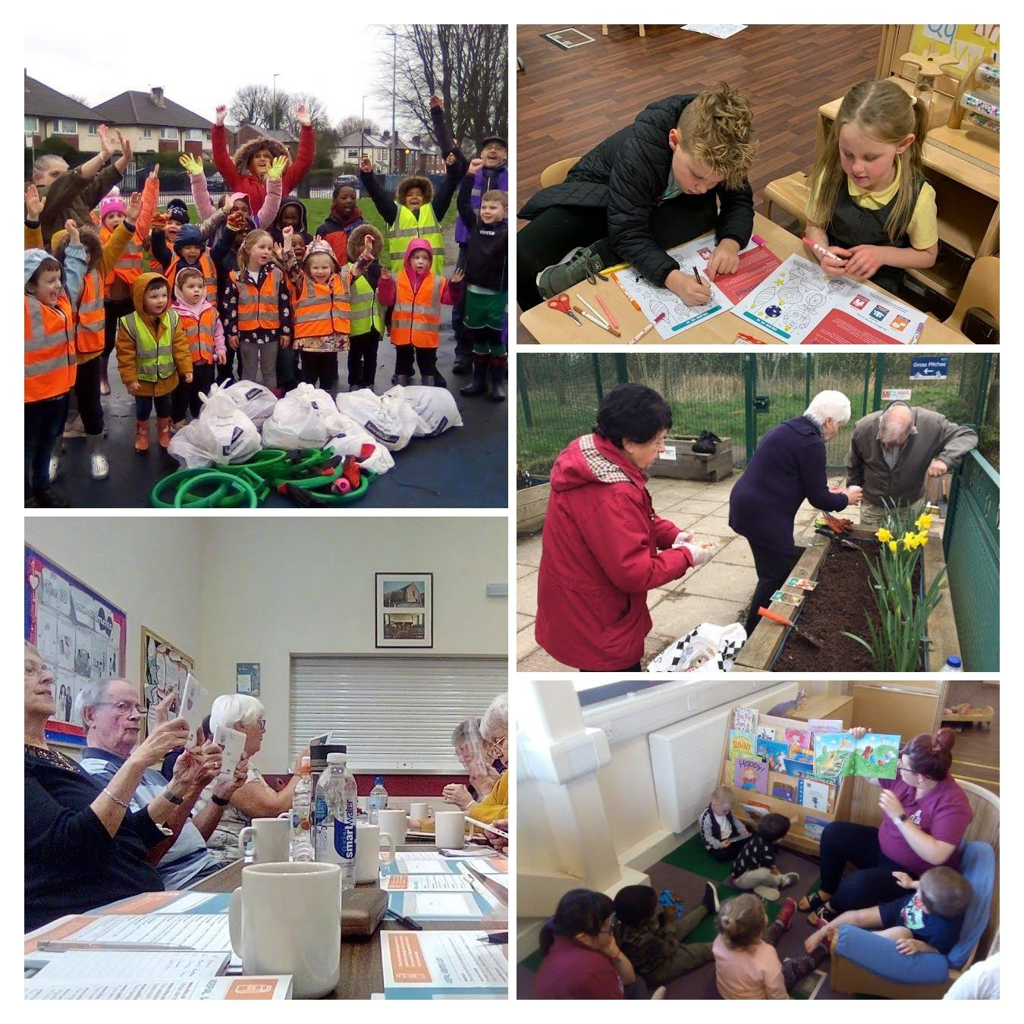

Development Worker (Age Friendly Salford)

Closing Date: 9am, 31st August 2021
Interview Date: TBC

Introduction

Thank you for considering applying for the role advertised. This pack has been created to help you learn more about Inspiring Communities Together and ensure that you complete a good quality application.

Further information about Inspiring Communities Together and the work we do can be found on our website: www.inspiringcommunitiestogether.co.uk

Please do visit our website as we want applicants to be able to understand who we are as an organisation and also to be able to demonstrate how their skills and experience meet the requirements of the advertised role.

Information for applicants

In this pack we have provided you with information and guidance to help you through the application process but should you have and difficulties please do not hesitate to contact Antonia Dunn, Operations Manager via email on antonia@inspiringcommunitiestogether.co.uk

All applications must be submitted by email and completed electronically. No handwritten applications will be accepted. We do not accept CVs; a full application form must be completed. Anyone submitting a CV or not completing the application as outlined below will not be considered by the panel.

Each applicant is required to submit the following information as part of the application process:
- The completed application form
- Equality monitoring form
- Details of 2 referees

Please return your completed documents by 9am, Tuesday 31st August 2021 to office@inspiringcommunitiestogether.co.uk with the reference AFS in the subject header.
Interview date to be confirmed

Acknowledgement and feedback
You will receive an email acknowledgement of your completed application. Should you be unsuccessful at the shortlist stage, you will be notified by email. Invitations to interview will be sent via email.

All unsuccessful applicants are welcome to ask for feedback on the reasons for not being shortlisted or selected at interview stage. Feedback for not being shortlisted will only be given by email. Feedback following non-selection at interview stage can be given by email or telephone at an agreed time.

Successful applicants are required to become members of Inspiring Communities Together. Thank you for your interest in Inspiring Communities Together. Please take care of yourself and those around you.

Yours sincerely
Bernadette Elder
Chief Executive Officer

Job Description – Development Worker (Age Friendly Salford)

Job title: | Development Worker (Age Friendly Salford)
Team: | Age Well
Salary: | £18,946 per annum FTE
Hours: | 35 hours per week / Fixed term 1 year contract (may be extended subject to securing additional funding)
Location: | This post will be offered on a blended working arrangement, working from the Innovation Forum, in the community across Salford (for which mileage will be paid) and at home.
Responsible to: | CEO

Job Overview

Working as part of the Age Well Team you will be part of the team responsible for the delivery of the Age Friendly Salford programme and will work across the various projects.

Main duties and responsibilities

Project delivery
- To deliver low level digital skills (Tech and Tea) sessions via Zoom and in the community (when safe to do so), and support the Tech and Tea drop-ins and Tech and Tech Online via Zoom
- To support and deliver the Age Friendly Engagement programme activities remotely via Zoom and in the community (when safe to do so).
- To deliver the lunch & learn informal learning programme, which includes falls prevention, malnutrition and hydration awareness and general health and wellbeing training
- To work closely with the development worker (Digital Inclusion) and development worker (Older People)
- To ensure timely and accurate recording and record keeping on the CRM and monitoring and evaluation forms and timely submission of case studies in line with agreed timelines

Other
- To support the Age Well team to achieve the wider team objectives
- To attend team meetings, supervision sessions and any external meetings as required
- To work flexibly and undertake, when required, other duties associated with supporting the needs of the organisation, which may be reasonably determined by the line manager and/or management team
- To work flexibly and attend occasional meetings and events outside normal working hours (evenings and weekends) for which notice will be given
- To undertake training and professional development as and when required

- Ensure high levels of professional conduct including punctuality, dress, presentation and administration
- Comply with the policies of Inspiring Communities Together at all times

Please note that because this job may involve working with young people and vulnerable adults, we will ask you to complete Enhanced DBS check. You must tell us in your application if you have any convictions, bind-overs or cautions, even if they are spent under the Rehabilitation of Offenders Act 1974. Please note that disclosing a conviction does not necessarily bar you from appointment.

Review arrangements
The details contained in this job description reflect the content of the job at the date it was prepared. It should be remembered, however, that it is inevitable that over time, the nature of individual jobs will change, existing duties may no longer be required and other duties may be gained without changing the general nature of the duties or the level of responsibility entailed. Consequently, the organisation will expect to revise this job description from time to time and will consult with the postholder at the appropriate time.

Date job description prepared/revised: | 29.06.21
Prepared/revised by: | Antonia Dunn
Agreed job description signed by holder:

Personal Specification

Note to applicants:

Whilst all criterions below are important, those under the Essential heading are the key requirements. You should pay particular attention to these areas and provide evidence of meeting them. Failure to do so will mean that you will not be invited for interview.

Essential criteria

Good, general IT competence (including setting up laptops/tablets, installing apps, Zoom, CRMs, email and using the internet)
Ability to problem-solve
Experience of facilitating groups including collecting and presenting information to achieve positive outcomes
Confidence in using the Microsoft Office suite including Word, Excel and PowerPoint
Excellent communication and interpersonal skills to communicate effectively with all stakeholders, from a variety of backgrounds and ages from young people to people aged 65+
Good Literacy and Numeracy Skills
Ability to plan and organise your own workload and manage your time
Ability to demonstrate an understanding of the ethos, values and operating environment of voluntary, community and social enterprise (VCSE) sector organisations
Desirable criteria

Education and learning level 3 award (PTTLS or equivalent)
Experience of direct working with and supporting groups of older people
Full clean driving licence with access to a car
Local resident of Charlestown, Lower Kersal, Seedley or Langworthy
To have experience, either paid or unpaid, of working in the voluntary and community sector
Personal qualities

Ability to act honestly, reasonably and with integrity
Active commitment to equality and diversity
Commitment to promoting the core values of the organisation

Inspiring Communities Together – Development Worker (Age Friendly Salford)
Application Form

Closing date for completed applications is 9am, Tuesday 31st August

Name: | Address:
Telephone No: | Email Address:
What attracts you to apply for this position?

Please tell us about any previous experience(s) you have that you feel are relevant?

Have you undertaken any previous training that you feel is relevant?

Do you have any particular needs that we should be aware of so as to best support you?

Please give the names and addresses of two people who are willing to provide a reference on your behalf. One referee should be your line manager/ supervisor from a current or last employer or volunteering supervisor
Referee 1:
Name:  Address: | Relationship to you:
 | Email:
Referee 2:
Name:  Address: | Relationship to you:
 | Email:
Do you consider that you have a disability? (a physical or mental impairment which has a substantial and long-term effect on your ability to carry out normal day-to-day activities) |  | Yes | No
Applicants from suitably qualified disabled people are positively welcomed

Personal Specification

Whilst all criteria listed below are important, Essential criteria are in bold. It is important that you address these in detail. Where possible, please try and give examples of how you meet these criteria.

Experience
- Experience of facilitating groups including collecting and presenting information to achieve positive outcomes
- Ability to plan and organise your own workload and manage your time
- Experience of direct working with and supporting groups of older people
- To have experience, either paid or unpaid, of working in the voluntary and community sector
Skills
- Good, general IT competence (including setting up laptops/tablets, installing apps, Zoom, CRMs, email and using the internet)
- Ability to problem solve
- Excellent communication and interpersonal skills to communicate effectively with all stakeholders, from a variety of backgrounds and ages from young people to people aged 65+
- Good Literacy and Numeracy Skills
- Full clean driving licence with access to a car
Knowledge
- Confidence in using the Microsoft Office suite including Word, Excel and PowerPoint
- Ability to demonstrate an understanding of the ethos, values and operating environment of voluntary, community and social enterprise (VCSE) sector organisations
- Level 3 Adult education qualification (PTTLS or equivalent)
- Local resident of Charlestown, Lower Kersal, Seedley or Langworthy
Personal qualities
- Ability to act honestly, reasonably and with integrity
- Active commitment to equality and diversity
- Commitment to promoting the core values of the organisation

Declarations
Are you related to any of the following?
- An employee of the organisation
- A Trustee of the organisation
Yes |  | No
If yes please state their name and relationship to you:

Immigration, Asylum and Nationality Act 2006

Under the Immigration, Asylum and Nationality Act 2006, you are required to provide evidence of your right to work in the UK. If called for interview you will be advised of the documents you will need to provide which will then be checked to ensure the organisation complies with the current legislation.

If you have a national insurance number please write it here
Town of birth

Country of birth

I declare that the information give in this application form is accurate and that if it is subsequently discovered that any statement is false or misleading, my offer of employment may be withdrawn or I may be dismissed from my employment by the organisation without notice. I also agree to a medical examination if required.

If I am offered employment, I understand that it may be necessary for security and safeguarding purposes for Inspiring Communities Together to carry out a Disclosure and Barring check on any employees in positions which involve contact with vulnerable adults and children in the course of their work
Pleas tick here if have any objection to a DBS check being undertaken
I understand that for certain jobs, refusal may influence an offer of employment being made
signature |  | Date
If you are e mailing this form you will be asked to sign this application at interview

Applicants’ checklist
I have completed my declaration form
I have answered all the questions in person specification and given examples of how I meet the requirements
I have completed the equality monitoring form
I have given details of 2 referees

Inspiring Communities Together Equality Monitoring Form

At Inspiring Communities Together, we want to know that we are giving people equal opportunities throughout all aspects of our work. To ensure this happens we need to collect information from you. Please help us by answering the following questions

The information you provide will be used solely for monitoring purposes and will be treated as confidential

- I would describe my origin as (please tick as appropriate)

WHITE |  | MIXED BACKGROUND |  | ASIAN OR ASIAN BRITISH
English |  | White and Black Caribbean |  | Indian
Scottish |  | White and Black African |  | Pakistani
Welsh |  | White and Asian |  | Bangladeshi
Irish |  | Other mixed Background |  | Other Asian background
Other White background
BLACK OR BLACK BRITISH |  | CHINESE, CHINESE BRITISH OR OTHER ETHINIC GROUP
Caribbean |  | Chinese
African |  | Other background
Other Black background

2. | My gender is:
Male |  | □ | Female | □
Prefer to self-describe |  | □ | Prefer not to say | □

3. Please tick if you identify as LGBTQ+ □

4. Do you consider you have a disability? Yes No

5. Age: under 18 18-30 31-60 over 60

