Ref: 1.2.15
Membership Pack

Inspiring Communities Together
2018

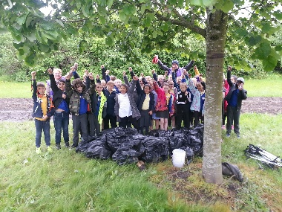
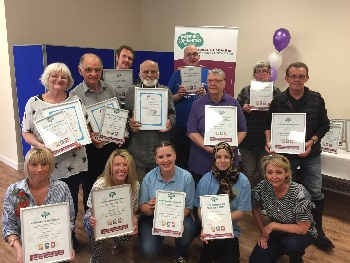
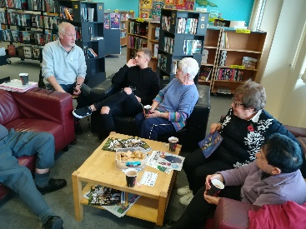

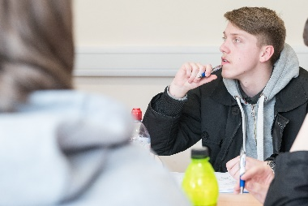
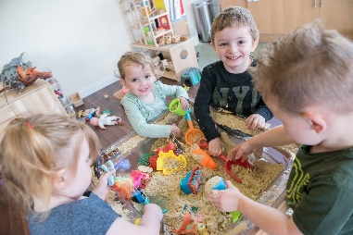
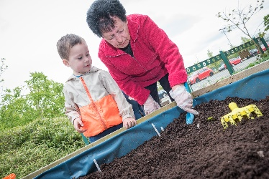

This handbook will be reviewed on a regular basis and amendments will be made where necessary. If you would like to suggest any changes or improvements to this booklet, please contact Bernadette Elder Chief Executive Officer Inspiring Communities Together

Thank you for your interest

Thank you for your interest in becoming a member of Inspiring Communities Together.

Please take the time to read the information included in this booklet.

This membership pack and application form has been produced to provide you with:

- Information about the organisation and what it does
- Information about the role of members within the organisation
- Information of how to apply to become a member

Completed and signed application forms can be passed to a member of the staff team or returned by post or handed in at the office:

Bernadette Elder
Chief Executive Officer
Inspiring Communities Together
Innovation Forum
Salford
M6 6FP

We look forward to hearing from you

Who we are and what we do

ICT – Who we are Vision, Mission, Organisational Objectives and Values

Vision – We will embed approaches which have worked locally in particular maintaining a culture of partnership working and working to retain specific interventions or activities where they have provided positive outcomes for local people based on the knowledge and information the community have about the area

Mission – We will achieve positive outcomes for local people based on the knowledge understanding and information that the community have about their area, through empowering individuals and groups to release their potential to develop their own solutions.

Values –
- We will be accountable to and representative of the local community
- We will be innovative and provide value for money in our approach to deliver of every- thing we do
- We will value all volunteers, staff and members of the organisation

Charitable objectives of Inspiring Communities Together –
- To develop the capacity and skills of those who are socially and economically disadvantaged by working with individuals and groups who live or work within the neighbourhood of Charlestown and Lower Kersal (CHALK) and neighbouring districts.
- To work with individuals and groups within these neighbourhoods to help them to make a difference locally.

What is the difference we are making (Outcomes) | How do we know we are making a difference  (our impact)
- Strengthening local Voices  - Improving peoples’ lives  - Creating better places to live | - Improve capacity and skills to feel more confident to try new things  - Improve self-confidence to get involved and make a difference  Nurture networking and share experiences

Our history

The organisation was established in September 2010 as the Development Framework Group (Charlestown and Lower Kersal) and built on the successes of the New Deal for Communities Regeneration Programme.

Between 2010 and 2013 a management committee made up of local residents, Councillors and services operating within the neighbourhood spent time developing the organisation, moving from a regeneration grant giving organisation to a community led anchor organisation and Charitable Incorporated Organisation –

Community Alliance’s definition of a community anchor organisation: Community anchors are independent community-led organisations. They are multi-purpose and provide holistic solutions to local problems and challenges, bringing out the best in people and agencies. They are there for the long term, not just the quick fix. Community anchors are often the driving force in community renewal

Inspiring Communities Together believe that by working in partnership across neighbourhoods positive outcomes can be achieved. The organisation recognises that they can use their skills and knowledge to support neighbourhoods along –side generating income to reinvest back into CHALK.

Our governance

In 2014 Inspiring Communities Together became a Charity Incorporated Organisation with a membership open to any-one aged over 16 years of age who lives. Works or volunteers within Charlestown and Lower Kersal. Priority is given to people who live in CHALK when filling the elected Trustees positions.

The governance of Inspiring Communities Together is delegated to a Board of Trustees both elected (6) and nominated (2 from Salford City Council and Salford University). The elected trustees are elected by the membership at the Annual General Meeting each year. The election process and terms of office is set out in the constitution (an electronic copy of the constitution can be provided by request).

All applications for membership must be agreed by the Board of Trustees of Inspiring Communities Together as outlined within the organisation’s constitution.

The day to day running of Inspiring Communities Together is delegated to the Chief Executive Officer who works closely with the Chair.

Financial planning

The funding for Inspiring Communities Together comes via a formal Annuity arrangement with Salford City Council alongside securing earned income for commissioned work. The Annuity funding supports our work in CHALK until 2046 and enables the organisation to deliver a programme of activity agreed each year by the Board of Trustees. The programme of activity is monitored by Salford City Council through a Service Level agreement which sets out the targets and outcomes the organisation must achieve for the funding. Earned income is now also starting to be secured by the organisation through commissioned pieces work and, in future the organisation is looking to access grants. Income generated by the organisation outside of the area of CHALK is used to benefit the residents of CHALK in the first instance.

Our delivery model

The delivery approach is built on a Test and Learn Asset Based model using the Annuity funding to test ideas and approaches and use the learning to scale up projects locally and/or use the learning to sell the approach. Developed over the past five years this approach now secures funding through contracts and grants and delivers projects wider than CHALK but any surplus income generated is for reinvestment back into the Neighbourhood of CHALK.

The day to day running of the organisation is carried out by a CEO alongside a team of staff – the majority of who are recruited from the local community. The Chair of the organisation also has a proactive role working with the CEO ensuring the community influence element of the organisation is delivered.

The organisation operates from a community space within the Innovation Forum. Much of the delivery is carried out in the neighbourhood through our 2 community hubs St Sebastian’s Community Centre and Salford Sports Village.

Measuring performance and impact

Between October 2012 and December 2012 we set out to work with the community to develop a set of community priorities for the neighbourhood linked to our programme of activity. This work was carried out using the Community Outcome Star model and set a baseline which ICT has used to measure impact of their work over the past five years.

Strengthening local voices
We will work to:
- Enable local residents of Charlestown and Lower Kersal to come together to identify key priorities within their neighbourhood and support the engagement of seldom heard voices.
- Provide a platform for local residents of Charlestown and Lower Kersal to share their stories of challenges and achievements

Improving people’s lives
We will work to:
- Deliver a programme of learning to support local residents of Charlestown and Lower Kersal to increase skills to help move into further learning or employment
- Support a programme of volunteering opportunities with accredited learning to provide a first step towards moving into further learning or employment
- Provide a programme of support to local community assets which will bring people together and support residents to age well

Creating better places to live
We will work to:
- Engage partners to support us to address environmental priorities across the area including flytipping/environmental improvements
- Ensure any physical development in the neighbourhood delivers quality and added value for the community
- Identify opportunities to minimise the impact of empty homes in the neighbourhood
- Provide resources through a commissioning pot and working along-side partners to access additional resources for the neighbourhood to deliver against community priorities (linked to community plan results and Forum priorities)

Membership process

Membership of Inspiring Communities Together is open to anyone aged over 16 years of age who:
- Lives in Charlestown or Lower Kersal
- Works/volunteers (including unpaid) in Charlestown and/or Lower Kersal

Anyone wishing to apply to become a member of Inspiring Communities Together should submit a completed application form and return to the organisation as detailed on the application form

- All applications will be considered by the Board of Trustees within 21 days of receipt of that application

- All applications will be advised of the decision of the Trustees. If the trustees decided to refuse an application the applicant will be advised in writing of the reason for their decision. Applicants will have the opportunity to appeal and fair consideration will be given by the Trustees, but any decision to confirm refusal of the application for membership will be final

- Membership of Inspiring Communities Together can-not be transferred to any-one else except in the case of an individual representing an organisation as outlined in the constitution.

Termination of membership

Every 2 years the board of Trustees will review the membership of the organisation and this may result in a membership being terminated. Reasons include:

- The member dies
- The member sends notice of resignation
- The member no long meets the requirements for being a member for example they no longer live or work (as defined by the Board) in the area of CHALK
- The member owes money to the organisation and has failed to repay within six months
- The member has failed to return their membership renewal form within the agreed timescale set (the individual may if this wish and can demonstrate they meet the membership criteria reapply for membership of the organisation in the usual way)
- The Board of Trustees feel it is in the best interest of the organisation, and pass a resolution to that effect (there is no right of appeal)

Before a decision can be taken to remove a member the trustees will:

- Inform the member of the reason why
- Give the member 21 days to make representation
- Discuss the decision at a constituted meeting and give the member the opportunity to make representation in person at that meeting

Membership fees

Inspiring Communities Together may require members to pay a reasonable membership fee of no more than £1.00. At this time no membership fee is payable

Roles and responsibilities

The role of members of Inspiring Communities Together is to:

- Act as the link between the wider community of Charlestown and Lower Kersal and Inspiring Communities Together
- Elect the trustees for the organisation
- Approve the annual report presented by the trustees
- Take an active role in the annual review of the work of Inspiring Communities Together
- Take an active role in setting the priorities for Inspiring Communities Together

The responsibility of members of Inspiring Communities Together is to:
.
- Uphold the values of Inspiring Communities Together
- To act in the best interests of Inspiring Communities Together
- To abide by and uphold the relevant policies of Inspiring Communities Together
- To accept decisions that were properly made by the trustees, even if they do not agree with them or were not present when they were made
- To keep informed about the work of Inspiring Communities Together by reading E newsletter and the website
- To declare any possible conflict of interest
- To consider the voluntary code of conduct regarding use of news media and social media when talking about ICT

Membership Application Form

Please complete all parts of the application form and return to the address below

Application form – Membership Inspiring Communities Together
Name: |  | Address:
Telephone No: |  | Email Address:
Please complete all sections which apply – If you do not live in the area of CHALK you must provide details of the organisation you work for
I confirm that I live in in the neighbourhood of CHALK |  |  |  |  |  |  |  |  | Yes |  |  |  |  |  | No
I confirm that I work for an organisation which is based in CHALK |  |  |  |  |  |  |  |  | Yes |  |  |  |  |  | No
Name of organisation
Activities delivered by the organisation in CHALK (please tick) |  | Early years |  | Education and learning |  |  |  | community |  |  |  |  |  | Older people |  |  |  | Youth
 |  | Local Business |  |  | Other (please specify)
If unpaid work number of hours volunteer |  |  | Per week |  |  |  |  |  |  |  |  |  | Per month
Name and signature of lead person in the organisation who supports your application (this should be CEO or Chair) |  | Name; |  |  |  |  | Signature:
Please tell us why you wish to become a member of Inspiring Communities Together?

I hereby apply for membership of Inspiring Communities Together and confirm that the details on this form are correct.
I agree to abide by the constitution of Inspiring Communities Together. (an electronic copy of the constitution is available on request)
I understand and agreed to fulfil my roles and responsibilities as a member of Inspiring Communities Together:
The role of members of Inspiring Communities Together is to: Act as the link between the wider community of Charlestown and Lower Kersal and Inspiring Communities Together, Elect the trustees for the organisation, Approve the annual report presented by the trustees, take an active role in the annual review of the work of Inspiring Communities Together take an active role in setting the priorities for Inspiring Communities Together

The responsibilities of members of Inspiring Communities Together is to: Uphold the values of Inspiring Communities Together, To act in the best interests of Inspiring Communities Together, To abide by and uphold the relevant policies of Inspiring Communities Together, To accept decisions that were properly made by the trustees, even if they do not agree with them or were not present when they were made, To keep informed about the work of Inspiring Communities Together by reading E newsletters and the website, To declare any possible conflict of interest, To consider the voluntary code of conduct regarding use of news media and social media when talking about ICT
I understand that if I no longer fulfil the membership requirements set out above my membership can be terminated
Date
Signature
The information on this form may be reproduced in a directory of members. Please tick the relevant box if you would like your email address included |  |  |  |  |  |  |  |  |  |  | YES |  |  |  |  | NO
Internal – for office use
Date application received
Date application considered by Trustees
Decision of Trustees |  | Approved |  |  |  |  |  |  |  | Refused
Reason for refusal
Signature of Chair
Details added to membership list
Letter sent to individual confirming decision
Please return to:
Bernadette Elder, Chief Executive Officer
Inspiring Communities Together,
Innovation Forum, Frederick Road, Salford, M6 6FP

